Lab Assignment 4.1
Ai Assisted Coding

2303A51700
BATCH_28

Problem Statement 1: Customer Email Classification

Step 1: Prepare Sample Emails
Email ID | Email Text | Category
E1 | I was charged twice for my last bill | Billing
E2 | My app is crashing when I log in | Technical  Support
E3 | The service is very good, keep it up | Feedback
E4 | Can you add dark mode feature? | Feedback
E5 | Just saying hello | Others

Step 2: Zero-shot Prompt (NO EXAMPLE)

Classify the following customer email into one of these categories: Billing, Technical Support, Feedback, Others.

Email: "I was charged twice for my last bill"
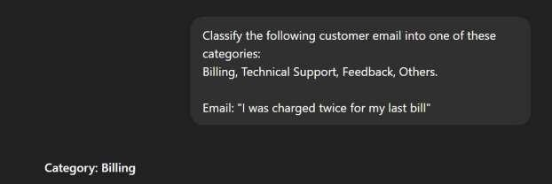

Observation:

The model correctly classified the email without any examples.

Step 3: One-shot Prompt (ONE EXAMPLE):

Example:
Email: "My internet is not working"
Category: Technical Support

Now classify the following email into
Billing, Technical Support, Feedback, or Others.
Email: "I was charged twice for my last bill"
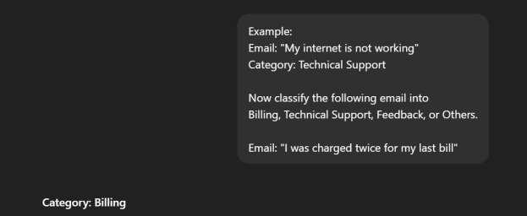
Observation:
Providing one example improved clarity.

Step 4: Few-shot Prompt :

Example 1:
Email: "My internet is not working"
Category: Technical Support

Example 2:
Email: "Thank you for great service"
Category: Feedback

Example 3:
Email: "I was charged extra this month"
Category: Billing

Now classify the following email:
Email: "I was charged twice for my last bill"

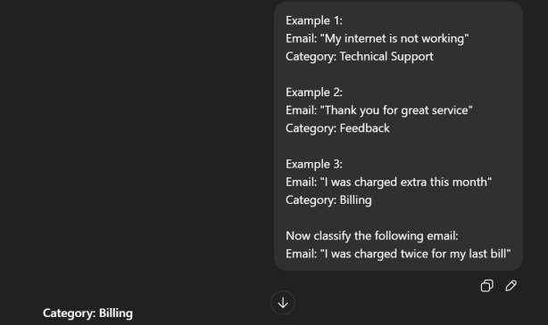
Observation:

Few-shot prompting gave the most confident and accurate output.

Problem Statement 2: Intent Classification for Chatbot Queries

Query ID | User Query | Intent
Q1 | I forgot my account password | Account Issue
Q2 | Where is my order right now? | Order Status
Q3 | Does this laptop support Windows 11? | Product Inquiry
Q4 | How can I contact customer care? | General  Question
Q5 | My account is locked | Account Issue
Q6 | When will my product be delivered? | Order Status

2. Zero-shot Prompting
Prompt:

Classify the following user query into one of these intents:
Account Issue, Order Status, Product Inquiry, General Question.

Query: "Where is my order right now?"
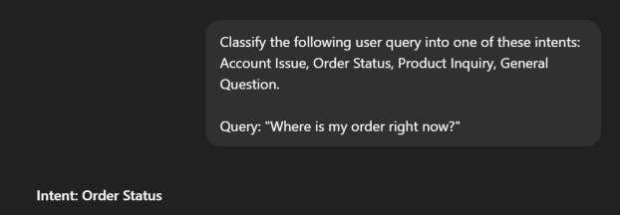

3. One-shot Prompting
Prompt:

Example:
Query: "I forgot my account password"
Intent: Account Issue

Now classify the following query:
Query: "Does this laptop support Windows 11?"

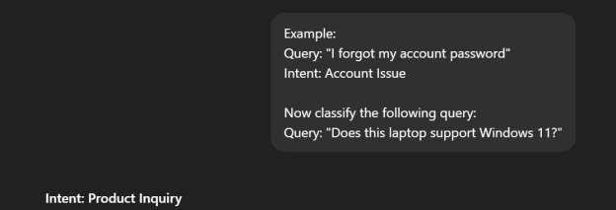

4. Few-shot Prompting
Prompt:

Example 1:
Query: "My account is locked"
Intent: Account Issue

Example 2:
Query: "When will my order arrive?"
Intent: Order Status

Example 3:
Query: "Does this phone support 5G?"
Intent: Product Inquiry

Example 4:
Query: "How do I contact customer care?"
Intent: General Question

Now classify the following query:
Query: "Where is my order right now?"

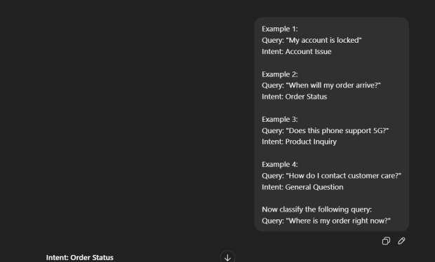

Observation:

Zero-shot works but may be slightly inconsistent.
One-shot improves understanding of intent categories.

Few-shot gives the most accurate and confident results.

Problem Statement 3: Student Feedback Analysis

a) Zero-shot Prompt
Classify the following student feedback as Positive, Negative, or Neutral.
Feedback: "The course content was very helpful and well explained."

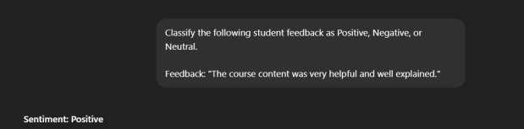

b) One-shot Prompt

Example:
Feedback: "The lectures were boring and confusing."
Sentiment: Negative

Now classify the following feedback:
Feedback: "The instructor explained concepts clearly."
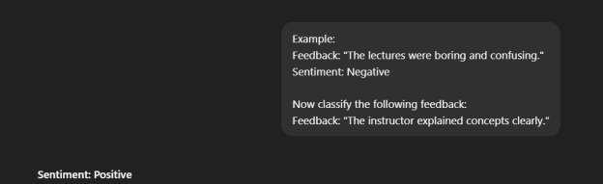

c) Few-shot Prompt

Example 1:
Feedback: "The classes were engaging and informative."
Sentiment: Positive

Example 2:
Feedback: "The syllabus is okay but needs improvement."
Sentiment: Neutral

Example 3:
Feedback: "The course pace was too fast."
Sentiment: Negative

Now classify the following feedback:
Feedback: "The assignments were manageable and useful."
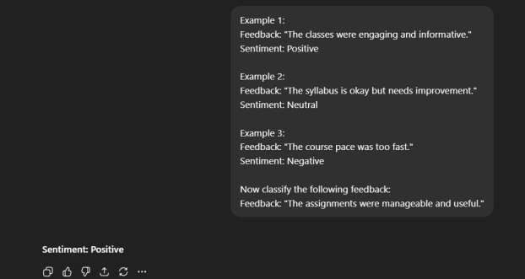

Observation:

Providing examples helps the model better understand tone and context, leading to more accurate sentiment classification.

Problem Statement 4: Course Recommendation System

a) Zero-shot Prompt

Classify the following learner query as Beginner, Intermediate, or Advanced.
Query: "I am new to programming and want to learn Python."
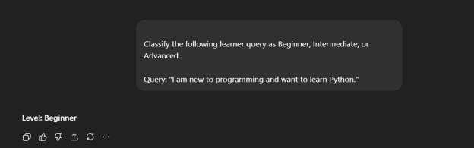

b) One-shot Prompt

Example:
Query: "I have never coded before"
Level: Beginner

Now classify the following query:
Query: "I know basics of Java and want to learn Spring Boot."

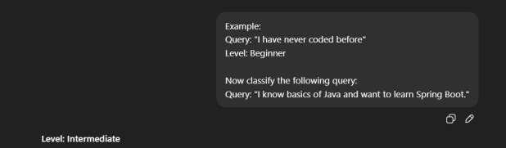

c) Few-shot Prompt

Example 1:
Query: "I am new to programming"
Level: Beginner

Example 2:
Query: "I understand OOP concepts"
Level: Intermediate

Example 3:
Query: "I want to master system design and algorithms"
Level: Advanced

Now classify the following query:
Query: "I know basics of Java and want to learn Spring Boot."

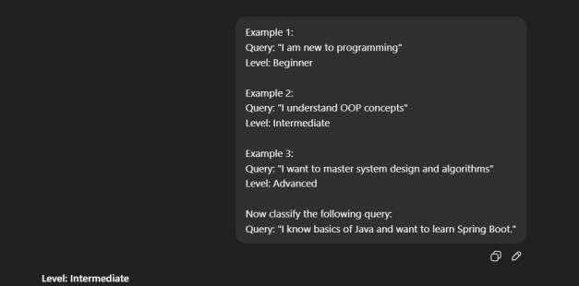

d) Discussion
Few-shot prompting improves recommendation quality by giving clearer boundaries between skill levels.

Problem Statement 5: Social Media Post Moderation

a) Zero-shot Prompt

Classify the following social media post as Acceptable, Offensive, or Spam.
Post: "Click this link to win free prizes now!"
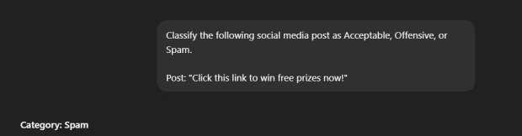

b) One-shot Prompt
Example:
Post: "Buy followers instantly!"
Category: Spam

Now classify the following post:
Post: "Click this link to win free prizes now!"

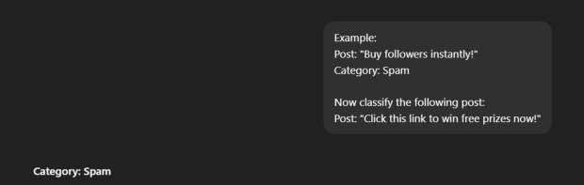

c) Few-shot Prompt

Example 1:
Post: "This product is amazing!"
Category: Acceptable

Example 2:
Post: "You are useless and stupid"
Category: Offensive

Example 3:
Post: "Buy followers instantly!"
Category: Spam

Now classify the following post:
Post: "Click this link to win free prizes now!"

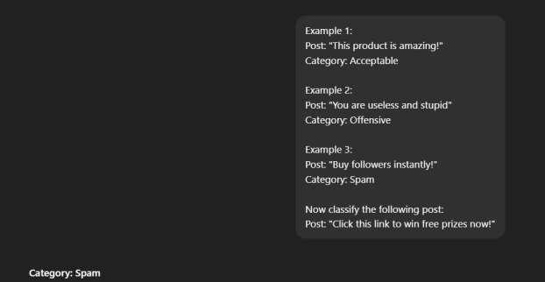

d) Explanation
Zero-shot prompting can struggle with slang, sarcasm, or hidden spam, whereas examples help the model understand subtle patterns.

